Day 1-5: Build and Configure a small Office Network Deliverable
Q1. Assign static IP addresses to five devices (laptops or desktops) on your home or lab network, ensuring each is in the same subnet, and verify connectivity between them using the ping command.
Ans:
Step 1: Create the Network Topology
- Place 1 Switch and 5 PCs (PC0, PC1, PC2, PC3, and PC4) in Cisco Packet Tracer.
- Connect all PCs to the Switch using Copper Straight-Through cables.
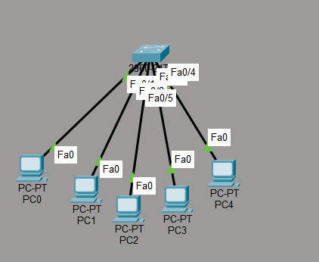
Figure 1: Network Topology

Step 2: Configure Static IP Addresses
Open each PC and navigate to:
Desktop → IP Configuration → Static
Assign the following IP addresses:
Device | IP Address | Subnet Mask | Default Gateway
PC0 | 192.168.1.10 | 255.255.255.0 | 192.168.1.1
PC1 | 192.168.1.11 | 255.255.255.0 | 192.168.1.1
PC2 | 192.168.1.12 | 255.255.255.0 | 192.168.1.1
PC3 | 192.168.1.13 | 255.255.255.0 | 192.168.1.1
PC4 | 192.168.1.14 | 255.255.255.0 | 192.168.1.1

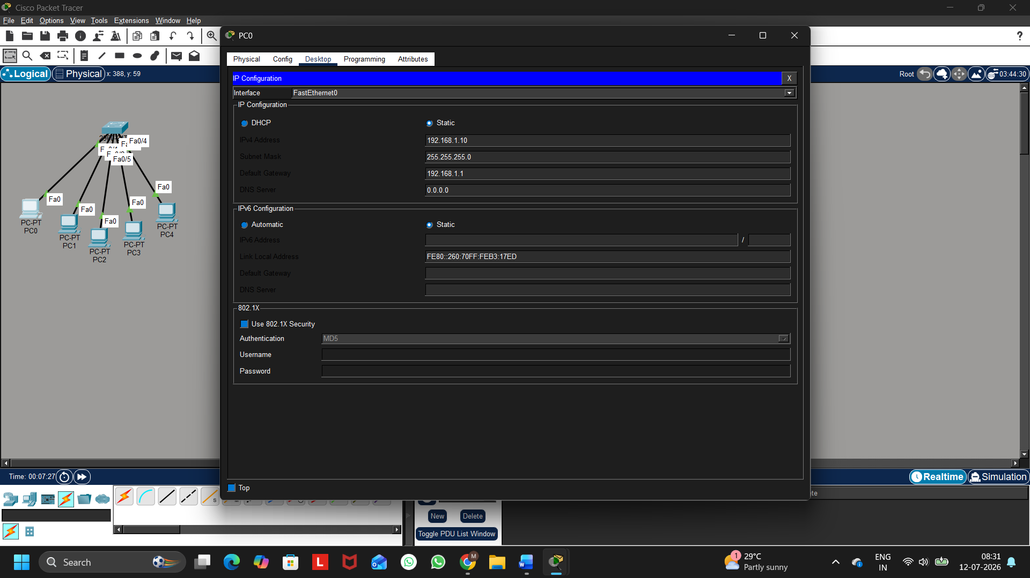
Figure 2: Static IP Configuration

Step 3: Verify Network Connectivity
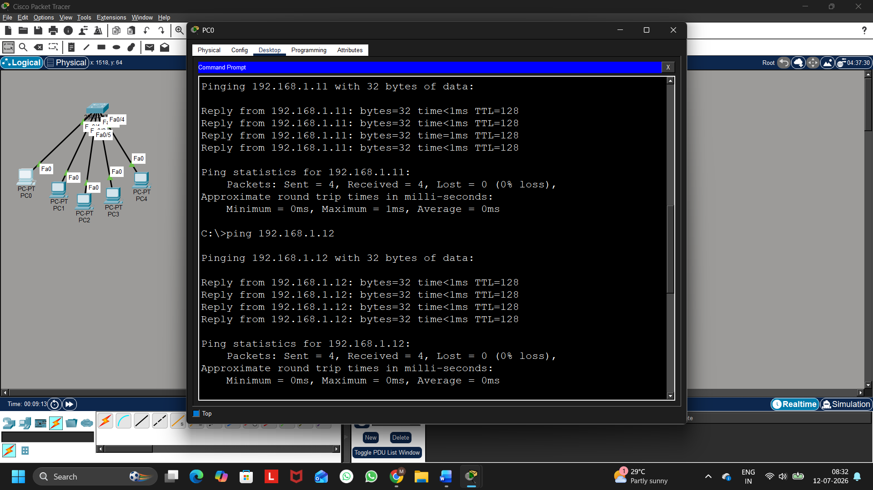
Figure 3: Successful Ping Verification for PC1 and PC2
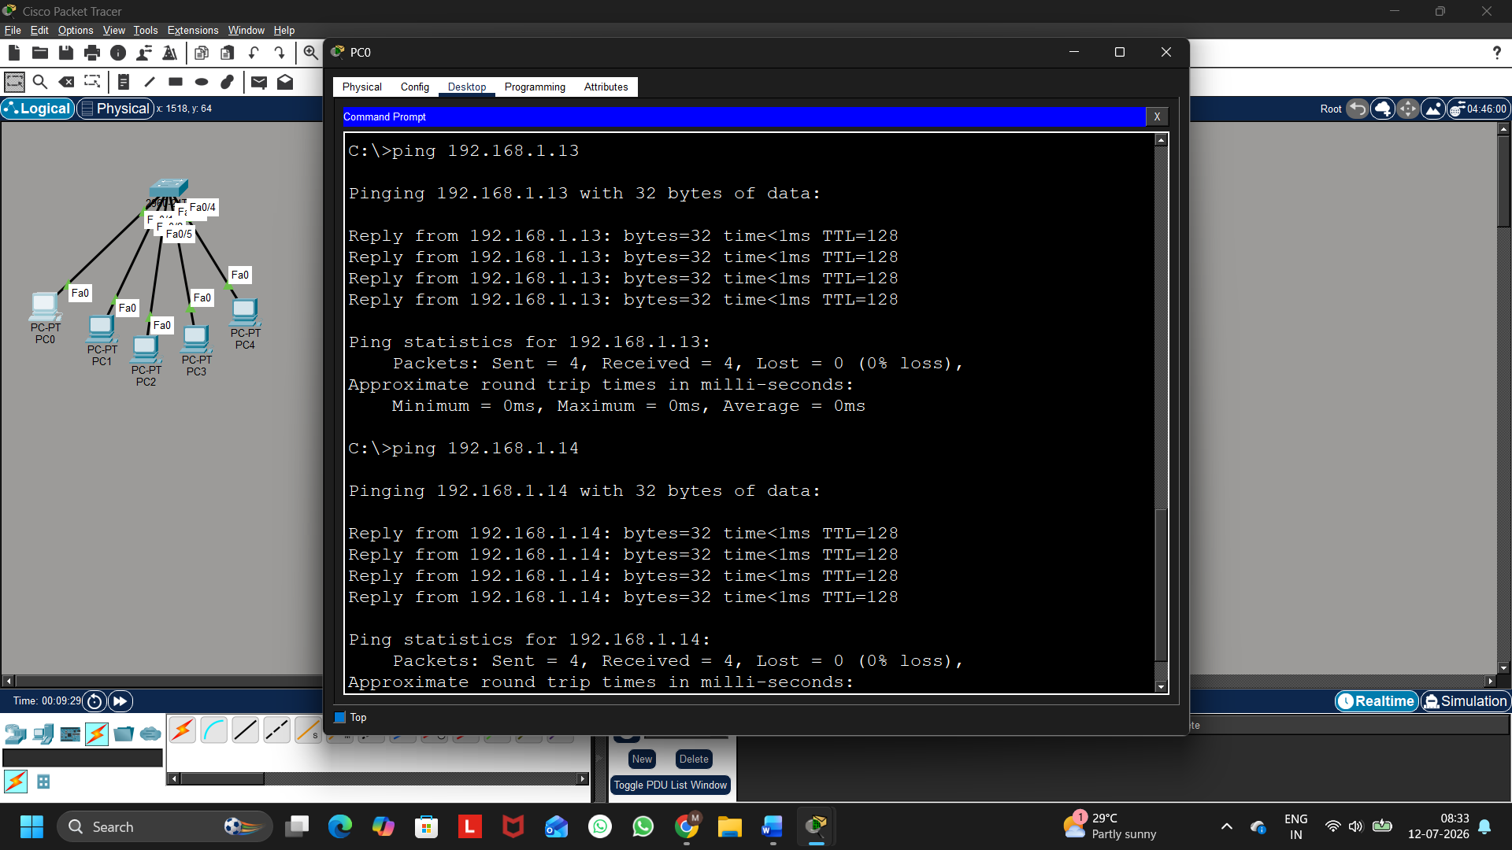
Figure 3: Successful Ping Verification for PC3 and PC4

Five devices were successfully assigned static IP addresses within the same subnet. Connectivity between the devices was verified using the ping command, and all devices responded successfully, confirming proper network communication.

Q2. Set up a DHCP server (using your router or software like Packet Tracer/GNS3/VirtualBox) to automatically assign IP addresses to at least three devices, and confirm that each device receives a unique IP from the correct range.
Ans:
Step 1: Create the Network Topology
- Place the following devices in Cisco Packet Tracer:
  - 1 Server
  - 1 Switch
  - 3 PCs (PC5, PC6, and PC7)
- Connect all devices to the Switch using Copper Straight-Through cables.

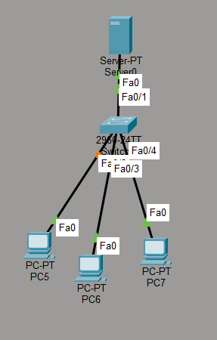
Figure 1: Network Topology

Step 2: Configure the Server
Open Server → Desktop → IP Configuration and configure:
- IP Address: 192.168.1.2
- Subnet Mask: 255.255.255.0
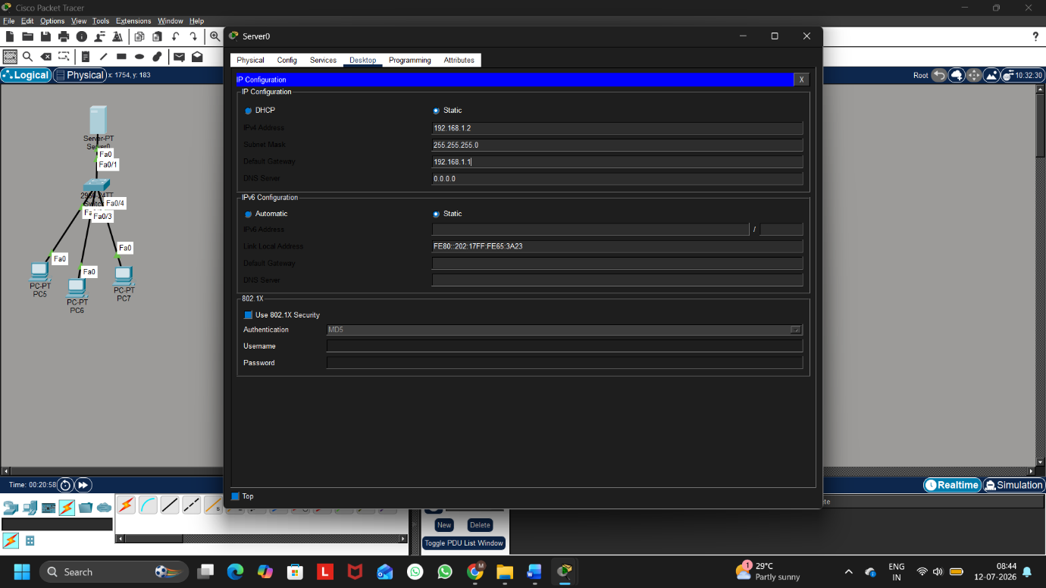
- Default Gateway: 192.168.1.1
Figure 2: Server IP Configuration
Step 3: Configure the DHCP Server
Go to:
Server → Services → DHCP
Turn DHCP Service = ON
Create a DHCP Pool with the following configuration:
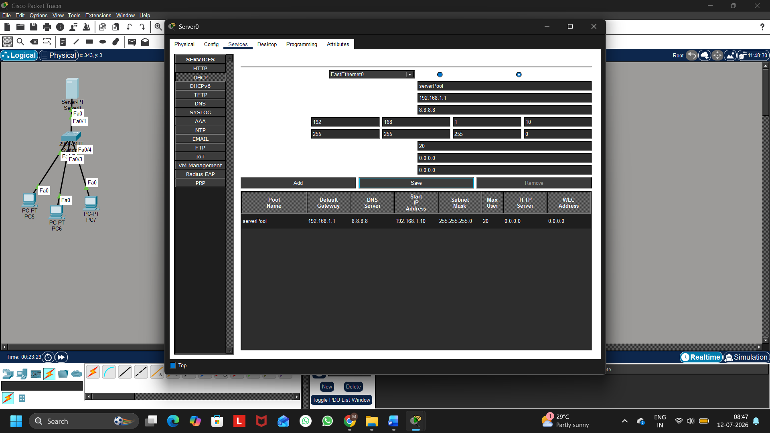
Figure 3: DHCP Server Configuration

Step 4: Configure the Client PCs
For each PC:
Desktop → IP Configuration → DHCP
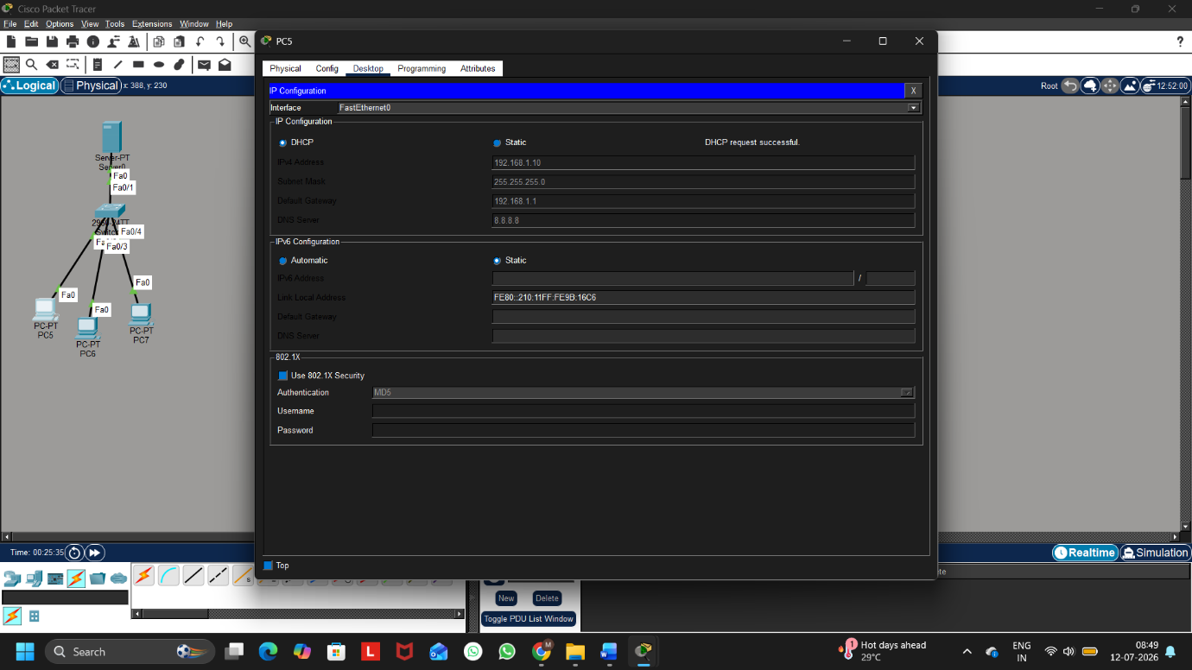
The DHCP server will automatically assign an IP address.
Figure 4: PC5 Receiving DHCP Address

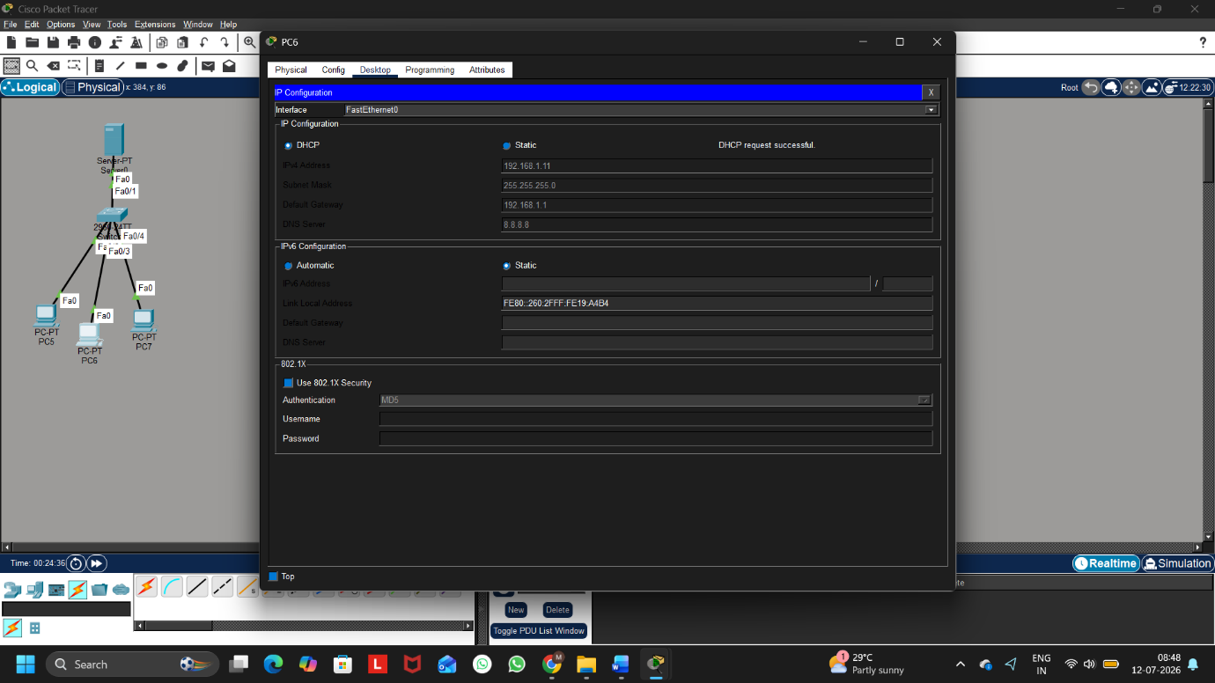
Figure 5: PC6 Receiving DHCP Address

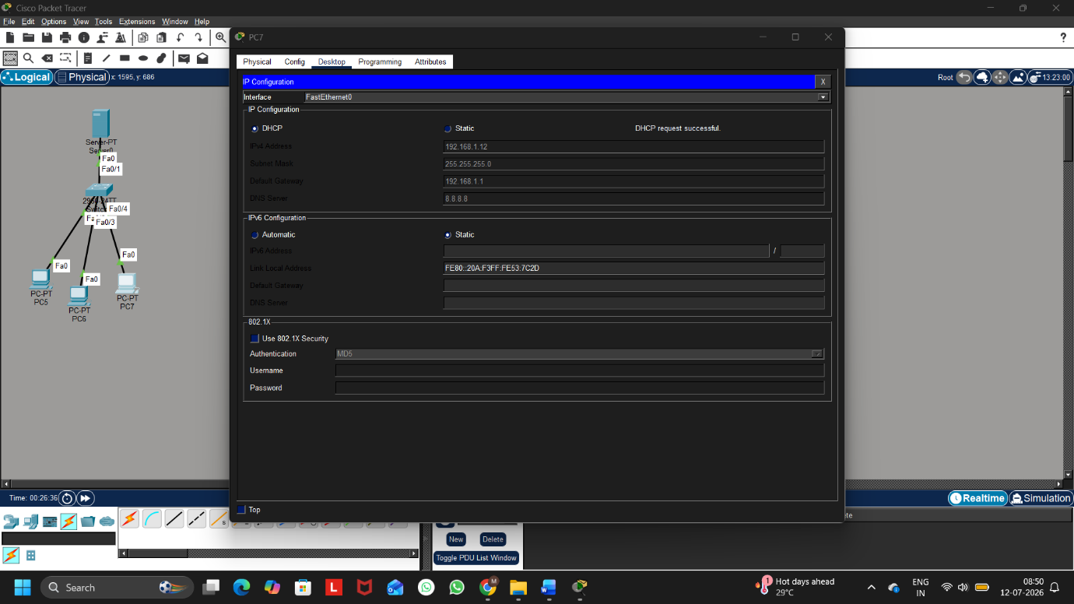
Figure 6: PC7 Receiving DHCP Address
Device | Assigned IP Address
PC | 192.168.1.10
PC6 | 192.168.1.11
PC7 | 192.168.1.12

Q3. Configure a DNS service (using your router’s DNS settings or a tool like dnsmasq) so that typing a custom hostname (e.g., musicplayer.local) in a browser on any connected device opens a specific local web page or device interface.<br><br><em><strong>Hint:</strong> You can map hostnames to local IPs using the DNS service or by editing the hosts file for a quick test.</em>
Ans:
Step 1: Create the Network Topology
Add the following devices:
- 1 Server
- 1 Switch
- 1 PC
Connect all devices using Copper Straight-Through cables.

Step 2: Configure the Server
Go to
Desktop → IP Configuration
Configure:
Setting | Value
IP Address | 192.168.1.2
Subnet Mask | 255.255.255.0
Default Gateway | 192.168.1.1

Step 3: Configure the DNS Service
Go to
Services → DNS
Turn
DNS = ON
Add the following DNS Record:
Name | Address
musicplayer.local | 192.168.1.2
Click
Add
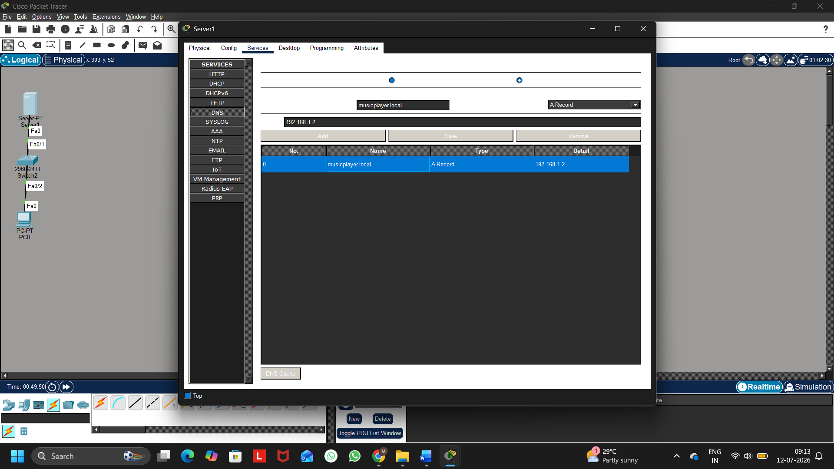
Figure 1: DNS Service Configuration

Step 4: Configure the HTTP Service
Go to
Services → HTTP
Turn
HTTP = ON
(Optional)
Edit index.html
Example
<h1>Welcome to Music Player</h1>
Save the page.
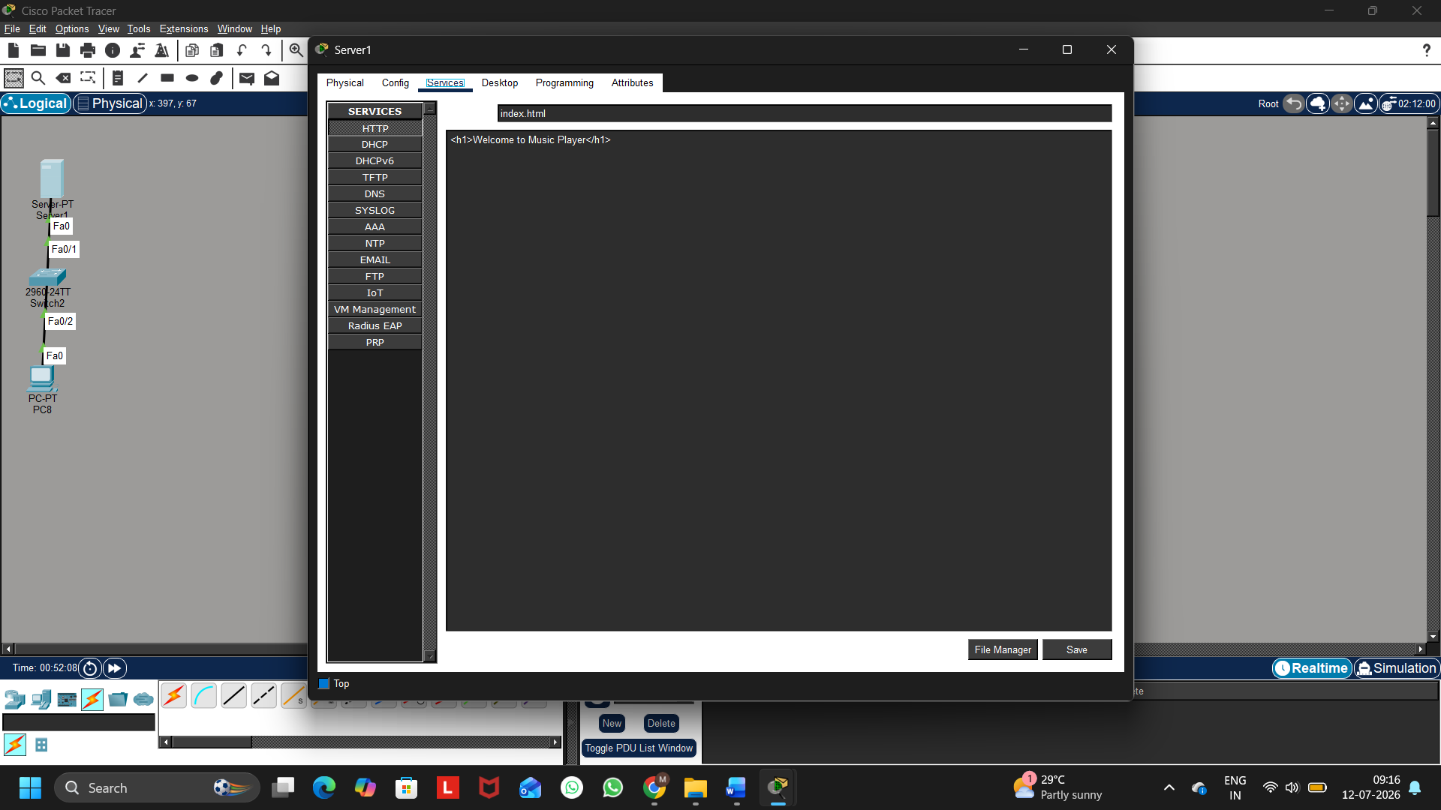
Figure 2: HTTP Service Configuration

Step 5: Configure the Client PC
Desktop
IP Configuration
Static
Configure
Setting | Value
IP Address | 192.168.1.10
Subnet Mask | 255.255.255.0
Default Gateway | 192.168.1.1
DNS Server | 192.168.1.2
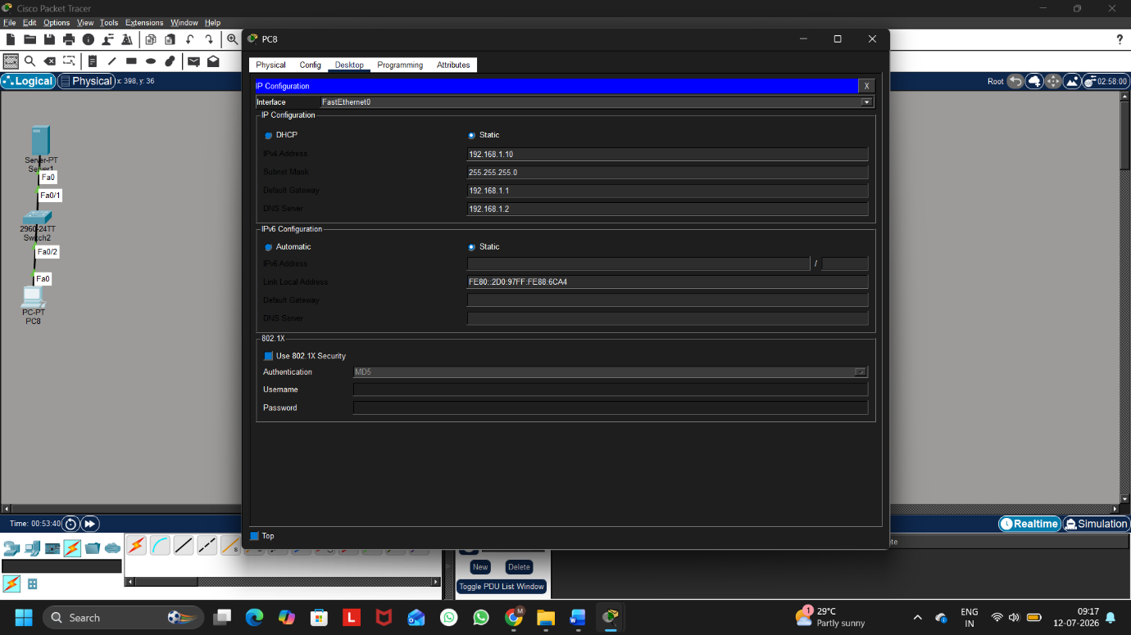
Figure 3: Client IP Configuration

Step 6: Verify DNS Resolution
Desktop
Command Prompt
Run
nslookup musicplayer.local
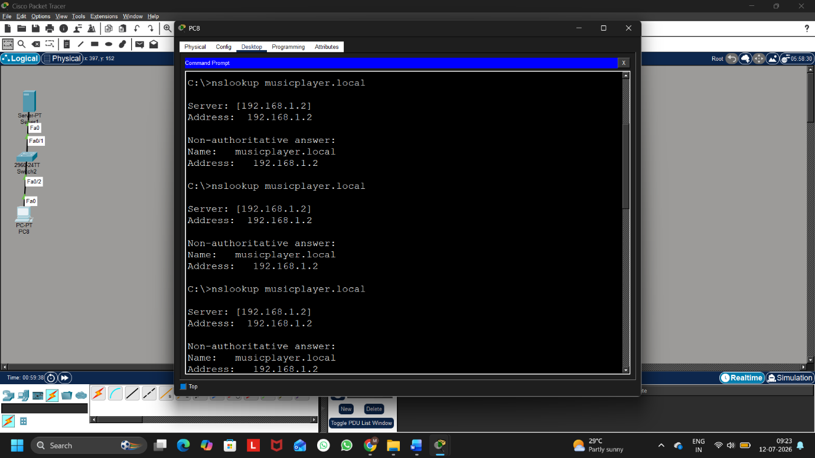
Figure 4: Successful DNS Lookup

Step 7: Open the Website
Desktop
Web Browser
Type
http://musicplayer.local
The browser opens the local webpage hosted on the Server.
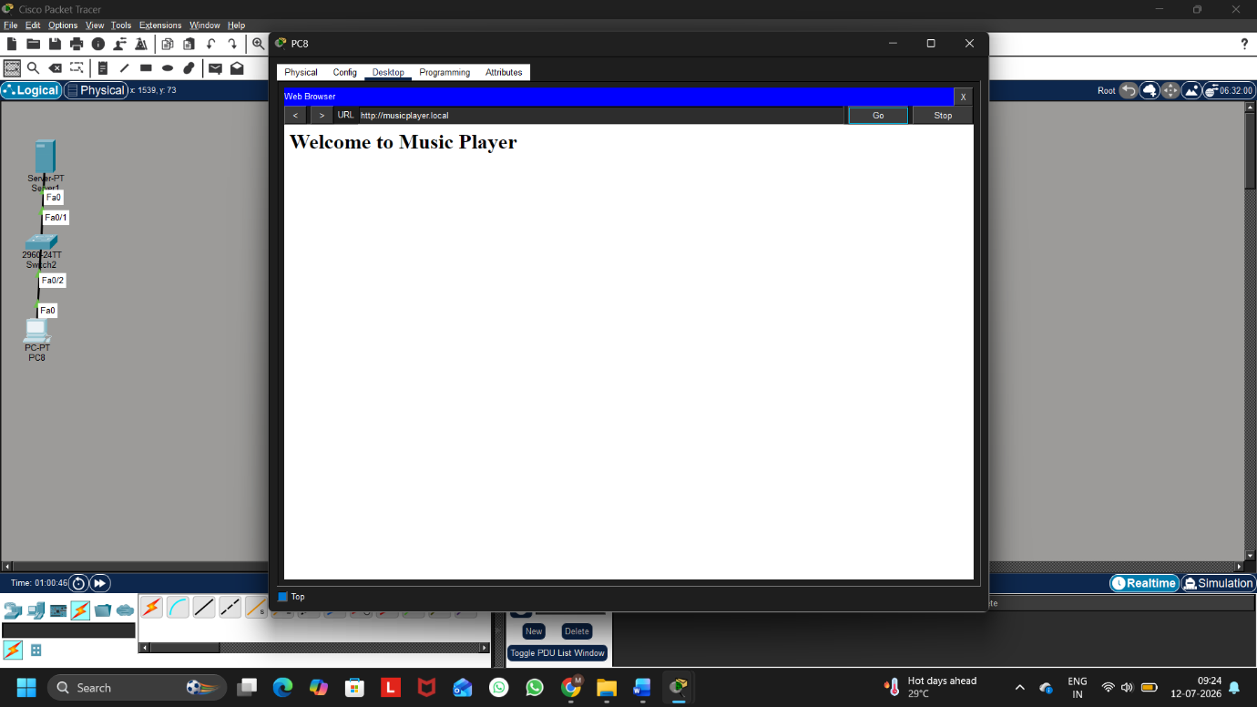
Figure 5: Local Web Page Opened Using Custom Hostname

The DNS service was successfully configured in Cisco Packet Tracer. A custom hostname (musicplayer.local) was mapped to the local server IP address (192.168.1.2). The hostname was verified using the nslookup command, and the webpage was successfully accessed through the browser using the custom hostname.

Q4. Create two VLANs (e.g., VLAN 10: 'Workstations', VLAN 20: 'Smart Devices') on your switch or simulation tool, assign at least two devices to each VLAN, and demonstrate that devices in the same VLAN can communicate, but not with devices in the other VLAN.<br><br><em><strong>Hint:</strong> Use ping or file sharing to test connectivity between devices in different VLANs.</em>
Ans:
Step 1: Create the Network Topology
Add:
- 1 Switch (2960)
- 4 PCs
Connections:
- PC0 → Fa0/1
- PC1 → Fa0/2
- PC2 → Fa0/3
- PC3 → Fa0/4
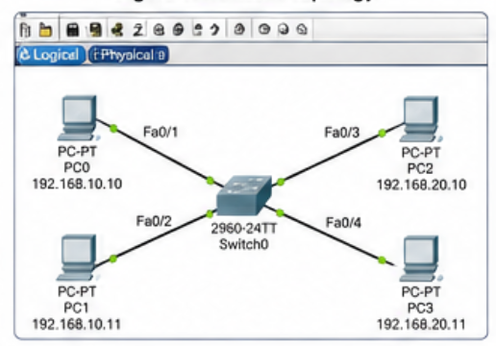

Step 2: Configure Static IP Addresses
Assign the following IP addresses.
VLAN 10 (Workstations)
Device | IP Address | Subnet Mask
PC0 | 192.168.10.10 | 255.255.255.0
PC1 | 192.168.10.11 | 255.255.255.0

VLAN 20 (Smart Devices)
Device | IP Address | Subnet Mask
PC2 | 192.168.20.10 | 255.255.255.0
PC3 | 192.168.20.11 | 255.255.255.0

Step 3: Create VLANs
Click the Switch
CLI
Type:
enable

configure terminal

vlan 10
name Workstations

exit

vlan 20
name SmartDevices

exit
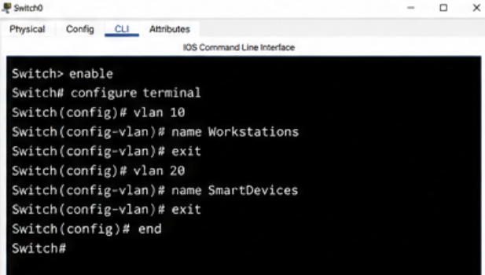
Figure 3: VLAN Creation

Step 4: Assign Ports to VLANs
Type:
interface fa0/1
switchport mode access
switchport access vlan 10
exit

interface fa0/2
switchport mode access
switchport access vlan 10
exit

interface fa0/3
switchport mode access
switchport access vlan 20
exit

interface fa0/4
switchport mode access
switchport access vlan 20
exit
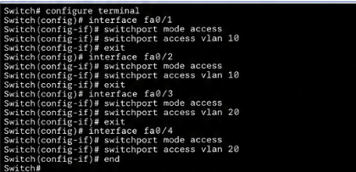

Step 5: Verify VLAN Configuration
Type:
show vlan brief
Output should show:
VLAN 10
Fa0/1
Fa0/2

VLAN 20
Fa0/3
Fa0/4
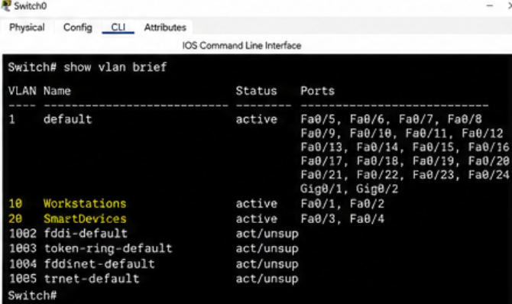
Figure 5: show vlan brief Output

Step 6: Test Communication Within the Same VLAN
From PC0
ping 192.168.10.11
Reply should be successful.
From PC2
ping 192.168.20.11
Reply should also be successful.
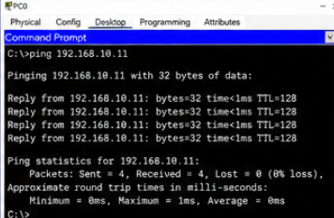
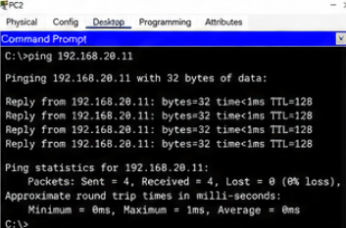
Figure 6: Successful Ping Within the Same VLAN

Step 7: Test Communication Between Different VLANs
From PC0
ping 192.168.20.10
Result
Request timed out
Similarly
From PC1
ping 192.168.20.11
Result
Request timed out
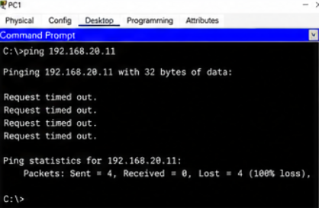
Because there is no router or Layer 3 switch configured, devices in different VLANs cannot communicate.
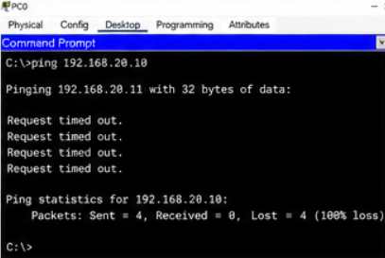
Figure 7: Failed Ping Between Different VLANs
Two VLANs (VLAN 10 and VLAN 20) were successfully created on the switch. Devices within the same VLAN communicated successfully using the ping command, while communication between different VLANs failed because inter-VLAN routing was not configured. This demonstrates how VLANs logically separate network traffic and improve network segmentation.

Q5. Simulate internet access for your LAN by configuring a router with NAT (Network Address Translation), then test that devices on your LAN can access an external site (e.g., www.wikipedia.org) or a simulated external server.
Ans:
Step 1: Create the Network Topology
Place the following devices:
- Router (2911)
- Switch (2960)
- PC0
- PC1
- External Server
Connect them as follows:
- PC0 → Switch
- PC1 → Switch
- Switch → Router (GigabitEthernet0/0)
- Router (GigabitEthernet0/1) → External Server
The router connects the internal LAN to the external network.

Step 2: Configure IP Addresses
Configure the following IP addresses.
Router
Interface | IP Address | Subnet Mask
G0/0 (LAN) | 192.168.1.1 | 255.255.255.0
G0/1 (WAN) | 200.1.1.1 | 255.255.255.0
PC0
Setting | Value
IP Address | 192.168.1.10
Subnet Mask | 255.255.255.0
Default Gateway | 192.168.1.1
PC1
Setting | Value
IP Address | 192.168.1.11
Subnet Mask | 255.255.255.0
Default Gateway | 192.168.1.1
External Server
Setting | Value
IP Address | 200.1.1.2
Subnet Mask | 255.255.255.0
Default Gateway | 200.1.1.1

Step 3: Configure Router Interfaces
Open the Router CLI and enter:
enable
configure terminal

interface g0/0
ip address 192.168.1.1 255.255.255.0
no shutdown
exit

interface g0/1
ip address 200.1.1.1 255.255.255.0
no shutdown
exit
These commands configure the LAN and WAN interfaces.

Step 4: Configure NAT
Enter the following commands:
access-list 1 permit 192.168.1.0 0.0.0.255

interface g0/0
ip nat inside
exit

interface g0/1
ip nat outside
exit

ip nat inside source list 1 interface g0/1 overload
These commands configure PAT (Port Address Translation), allowing multiple LAN devices to use one public IP address.

Step 5: Verify NAT Configuration
Run the following command:
show ip nat translations
Example Output:
Pro Inside global Inside local Outside local Outside global

icmp 200.1.1.1 192.168.1.10 200.1.1.2 200.1.1.2
icmp 200.1.1.1 192.168.1.11 200.1.1.2 200.1.1.2
The output confirms that the router is translating private IP addresses into the public IP address.

Step 6: Test Connectivity
From PC0, open Desktop → Command Prompt and execute:
ping 200.1.1.2
Expected output:
Reply from 200.1.1.2:
bytes=32 time<1ms TTL=128

Reply from 200.1.1.2:
bytes=32 time<1ms TTL=128

Reply from 200.1.1.2:
bytes=32 time<1ms TTL=128

Reply from 200.1.1.2:
bytes=32 time<1ms TTL=128
This confirms successful communication with the external server through NAT.

Step 7: Verify Internet Simulation
If the external server is configured with HTTP service:
- Open Desktop → Web Browser
- Enter:
http://200.1.1.2
The webpage hosted on the external server should load successfully.

The router was successfully configured with Network Address Translation (NAT). The LAN devices accessed the simulated external server using the router's public IP address. The NAT translation table verified that private IP addresses were translated correctly, demonstrating how NAT enables multiple internal devices to share a single public IP address while accessing external networks.

